**Mission Idea 1 (Original Idea – Most fleshed out??):**

**Mission title:**

Taking down the web.

**Mission synopsis:**

Find abandoned Revolver Syndicate hideout close to the Arakni blood pod and gather scientist’s research. With new found research, find a way to destroy the blood pod before it contacts the Arakni for more reinforcements.

**Location:**

Eastern Europe – Interior of apartment buildings

**Mission style:**

Honestly not sure?? Ask about this.

**Mission rules:**

* Player has to clear out the apartments and find the hideout of the Syndicate.
* Player won’t be able to progress until they have gathered the intel on how to destroy the blood pod.
* Player has to destroy pod before it communicates with Arakni.

**Win/Lose conditions:**

Win Conditions – Arakni are all killed and blood pod is destroyed before it communicates with the other Arakni.

Loss Conditions – Player is killed or is unable to get to destroy the blood pod in time before it calls for reinforcements.

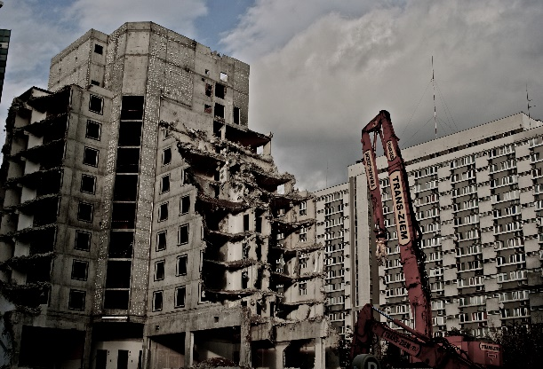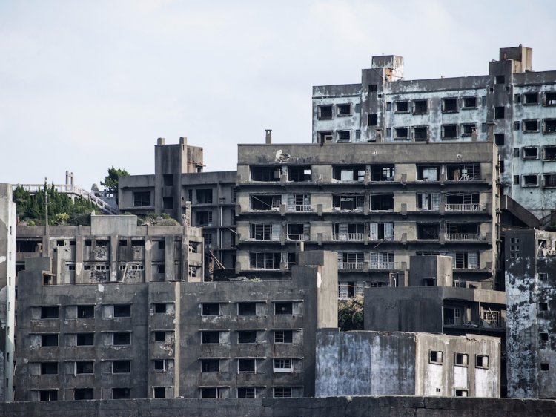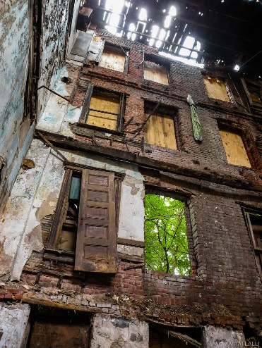

**Mission Idea 2 (Most Confident on):**

**Mission title:**

No Fly Zone.

**Mission synopsis:**

Take control of the missile silo and disarm the nuke before it is set off and takes out the remaining members of the Revolver Syndicate. (Will have to find a way to imply it accidently was primed to be sent off or that the Arakni are intelligent enough to prime a nuke?).

**Location:**

America – Military missile silo.

**Mission style:**

Honestly not sure?? Ask about this.

**Mission rules:**

Player has to kill enemies in each area before being able to progress to the next area.

**Win/Lose conditions:**

Win Conditions – Find and kill all of the Arakni and defuse the nuke before it is sent off and destroys Revolver Syndicate HQ.

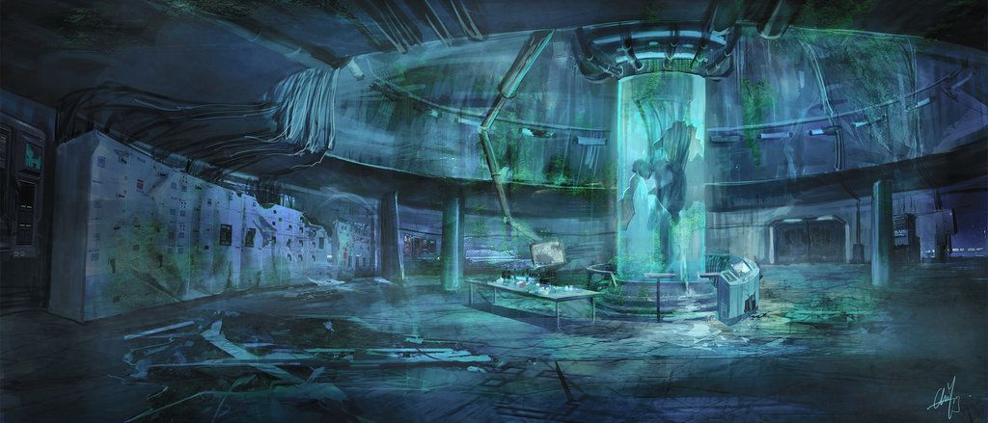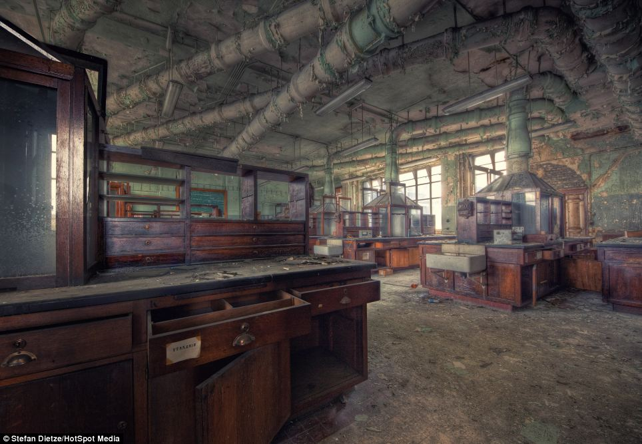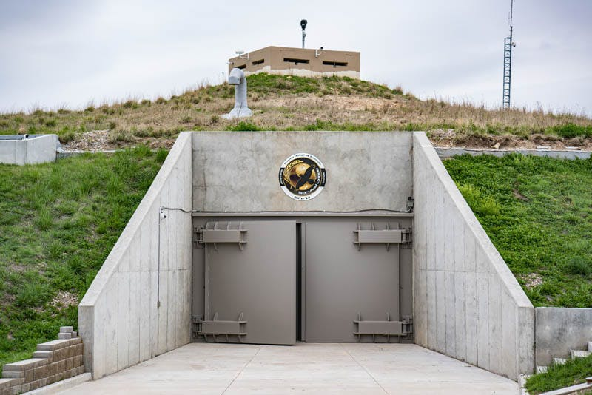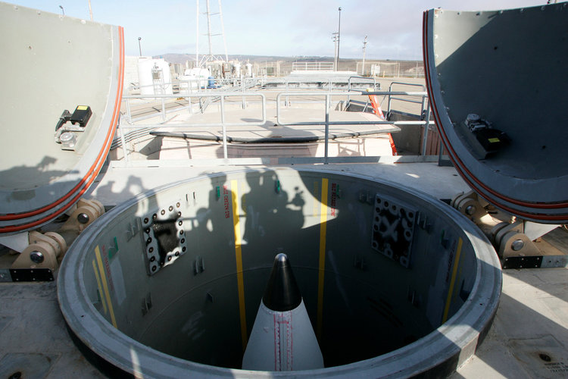Loss Conditions – Death or player fails to disarm the nuke and it destroys it’s target. (This may not be possible due to Deepak’s limitations to what can be changed but may still be an option).

**Mission Idea 3 (Unsure on but like idea of):**

**Mission title:**

The newlywebs (don’t worry, this name will be changed at some point).

**Mission synopsis:**

Find the breeding ground of the Arakni.

**Location:**

Chernobyl - The Black Zone (possibly in the heart of the failed reactor? Could hint they feed off radiation to breed).

Other possibility is to make it in an abandoned forest with an observatory?

**Mission style:**

Search and destroy??

**Mission rules:**

Not sure on rules for this one, ask for possible insight/advice.

**Win/Lose conditions:**

Win Conditions – Kill all of the Arakni’s in the breeding grounds and destroy the Black Zone to stop breeding.

Loss Conditions – Death.

